Handouts for Career Exploration Class

- Determine Your Values
- Identifying Skills through Past Enjoyable Activities
- Exploring Assessment and Career Exploration Resources on CareerForceMN.com
- Exploring ONet
- SMART Goals Worksheet

Upon request the information in this document can be made in alternative formats for people with disabilities by contacting INSERT PHONE NUMBER.
CareerForce is an Equal Opportunity Employer and Program Provider

Determine Your Values
Read the values listed below and rate then according to how important you consider them to be.

3 = Must Have 2 = Neutral 1= Care the least about
_____ Moral Values: Do work assignments without feeling that it is morally wrong
_____ Leadership: Directing or showing others how to do something
_____ Friendships: Develop close relationships with people as a result of work activities
_____ Helping Others: Be involved with helping people in a direct way, either individually or in
small groups
_____ Communication: Speak and/or write to/with others
_____ Location: Find a place to live which is conducive to your lifestyle and affords you the
opportunity to do the things you enjoy most
_____ Adventure: have work duties that involve frequent risk-taking
_____ Achievement: Work that gives you the feeling of accomplishment
_____ Creativity: Create new ideas, programs, organizational structures or anything else not
following a format previously developed by others
_____ Interest: Doing something because you like to do it
_____ Physical Challenge: Have a job that makes physical demands which you find rewarding
_____ Affiliations: Being recognized as a member of a particular organization of department
_____ Precision Work: Work in situations where there is very little tolerance for error
_____ Competition: Engage in activities which put me against others, where there are clear
win/lose outcomes
_____ Excitement: Experience a high degree or frequent stimulation in the course of work
_____ Aesthetics: Be involved in studying of appreciating the beauty of things, ideas, etc.
_____ Authority: Being able to tell people what to do
_____ Intellectual Status: Being regarded as a person of high intellectual power or as one who is
acknowledged as an expert in a given field
_____ Company Policies and Practices: Being someone who ensures an organization administers
policies fairly
_____ Knowledge: Engage yourself in the pursuit of knowledge, truth and understanding
_____ Recognition: Be recognized for the quality of your work in some visible, public way so that
people are aware of your accomplishments
_____ Influence: Change the attitudes or opinions of others— or alter their behavior
_____ Fast Pace Activity: Work in circumstances where work must be done rapidly
_____ Independence (Working Alone): Be able to determine the nature of your work without
significant direction from others— not to have to do what others tell you to
_____ Advancement: The opportunity to work hard and make rapid career progression
_____ Responsibility: Being able to make decisions on your own
_____ Duty: Doing what you know needs to be done; being responsible
_____ Creative Expression: Opportunity to express your ideas, reactions and observations
concerning your job and how you might improve
_____ Personal Loyalty of Supervisor: You get a strong feeling that your boss supports you
_____ Challenge: Being able to solve difficult problems and/or handle tough assignments that
might involve learning something
_____ Power: Using your leadership abilities to influence the direction of the organization
_____ Change and variety: Your work responsibilities vary
_____ Ability Utilization: Doing something that makes use of your abilities
_____ Interpersonal Relations: Developing a strong bond between people; helping them to work
harmoniously
_____ Counseling: Helping someone with a personal problem
_____ Honesty: Working in an environment that values (and displays) integrity
_____ Security: Being assured of keeping your job and receiving reasonable financial compensation
_____ Personal Satisfaction: Doing something that has meaning to you
_____ Compensation: Salary would compare well with that of other workers
_____ Respect: Feeling your work and your person are respected
_____ Travelling: Being able to go different places on your job
_____ Having time off of work: Having a generous benefits package
_____ Friendships: Develop close relationships with people as a result or work

Identifying Skills Through Past Enjoyable Activities

List 5 favorite activities (things you enjoyed doing, did well and were proud of). Try to pick specific instances of an activity you enjoyed, such as My Trip to Alaska rather than Traveling. Also think of past accomplishments you particularly enjoyed working on. Consider different areas of life such as education, work, leisure, family, volunteer, church, etc. Then list the SKILLS used for each activity or accomplishment.

Activity Skills Used
1. What did you especially enjoy in doing this?

2. What did you especially enjoy in doing this?

3 .What did you especially enjoy in doing this?

4. What did you especially enjoy in doing this?

5. What did you especially enjoy in doing this?

Which skills did you use most often? Of these, which do you most enjoy?

Exploring Assessment and Career Exploration Resources on CareerForceMN.com

Step 1: Go to CareerForceMN.com.

Step 2: Select Online Tools from the main menu bar


Step 3: Select Take an Interest Assessment or Take a Skills Assessment from the Online Tools page


Step 4. Take an interest assessment. There are 60 questions and completing the assessment will take about 10 minutes. There are no right or wrong answers. Just answer in the way that best describes your interests.
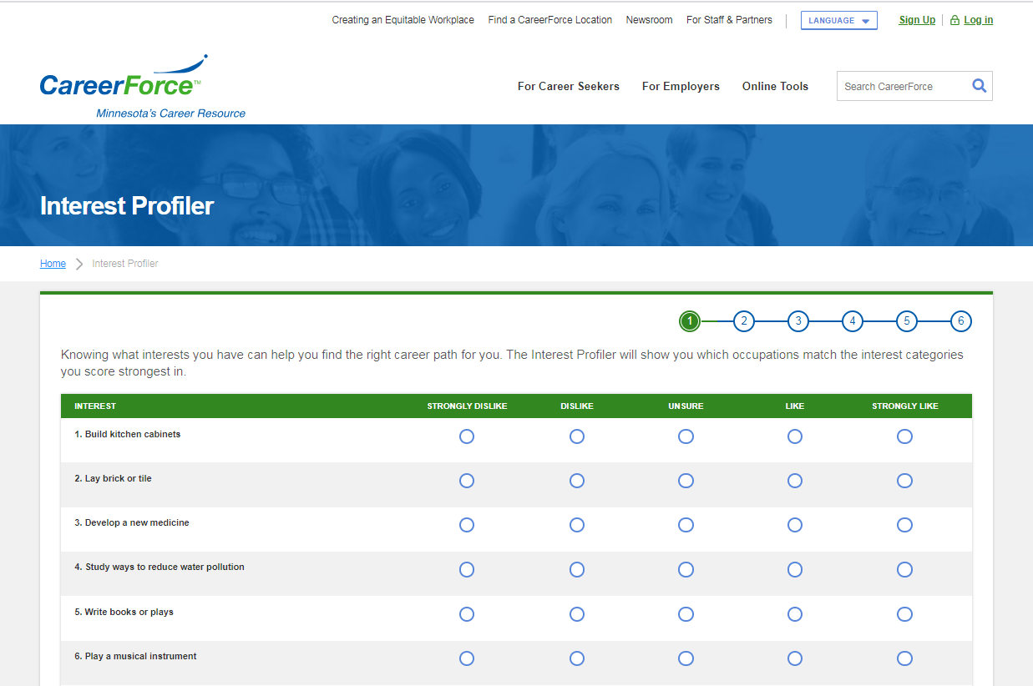

Step 5. After you complete and submit the interest assessment, the system will take a few seconds to review your responses and calculate your areas of interest, which you will see a results screen.
The interest assessment results screen shows how much your responses match with each of the six Holland RIASEC types, which are:
- Realistic
- Investigative
- Artistic
- Social
- Enterprising
- Conventional.
Your matches will be displayed in order of strongest match to weakest match. And further down on the page you will see a list of specific occupations that are a good match for your interests or skills, along with the following information for each recommended occupation: wage ranges for Minnesota, typical level of education required and demand (with a rating of stars for demand – no filled in starts means very little to no demand and five stars means very high demand). See screen shot of example results screen on the next page.

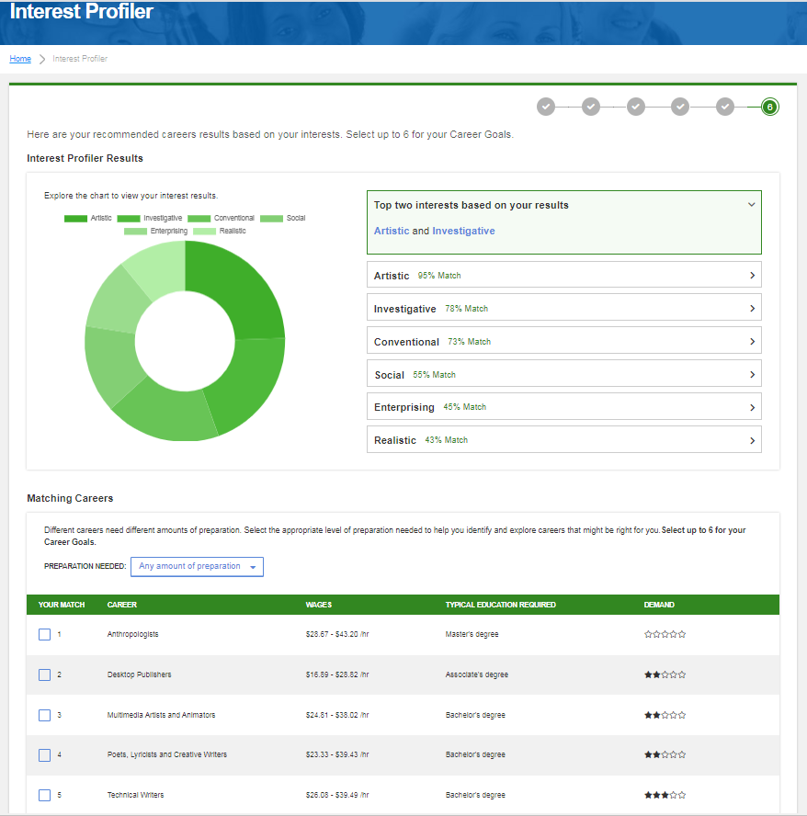

Step 6. You can further refine your results by selecting the level of preparation needed. Options are:
- Any Amount of preparation
- Little to no preparation
- Some preparation
- Medium preparation
- High preparation
- Extensive preparation
Below you can see the results requiring a high level of preparation matching this example person’s interests.

High preparation
Experience: Long term work-related skill, knowledge, or experience is needed for these careers. For example, an accountant must complete four years of college and work several years in the field to be qualified for the job.
Training: Employees in these careers need several years of work-related experience and training. Both on-the-job and classroom job training may be needed.
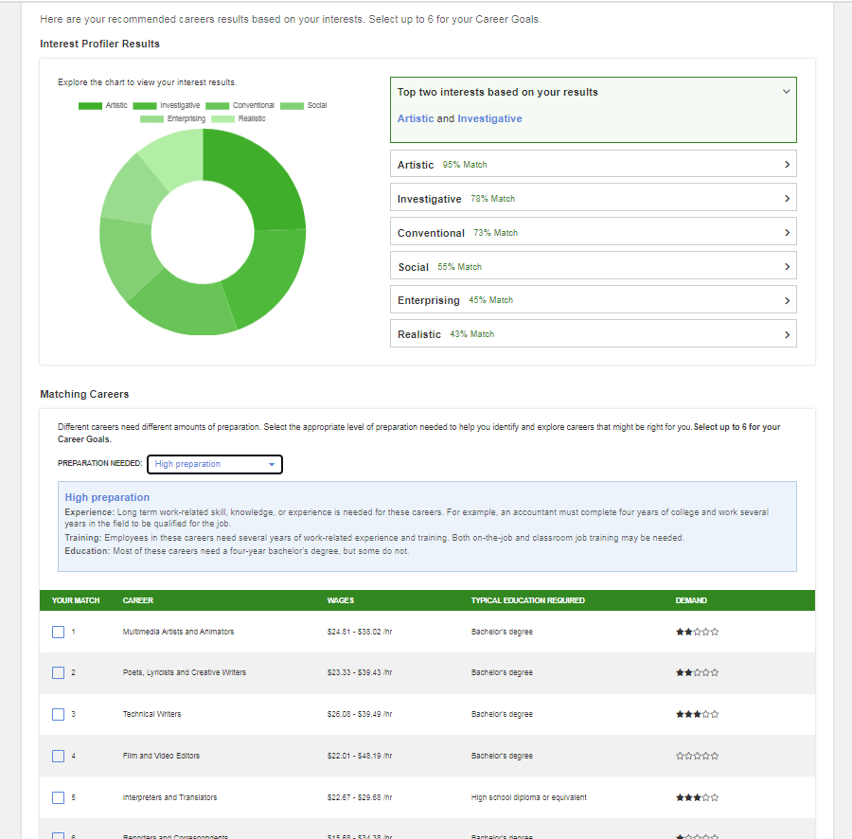
Education: Most of these careers need a four-year bachelor's degree, but some do not.

- Any Amount of preparation
- Little to no preparation
- Some preparation
- Medium preparation
- High preparation
- Extensive preparation

Step 7. Check the boxes under Your Match on the rows of occupations that match your interests and that you want to earn more about, then select Update Career Goals to add your selected occupations to your career goals and see additional details about those occupations and watch short videos about each occupation you select.

You can select up to six results to add to your career goals and see additional details about those occupations, as well as a short video. You need an account on CareerForceMN.com to set and save career goals and explore occupation details. It takes just a few minutes to set up your CareerForceMN.com. You will need an email address to set up an account.

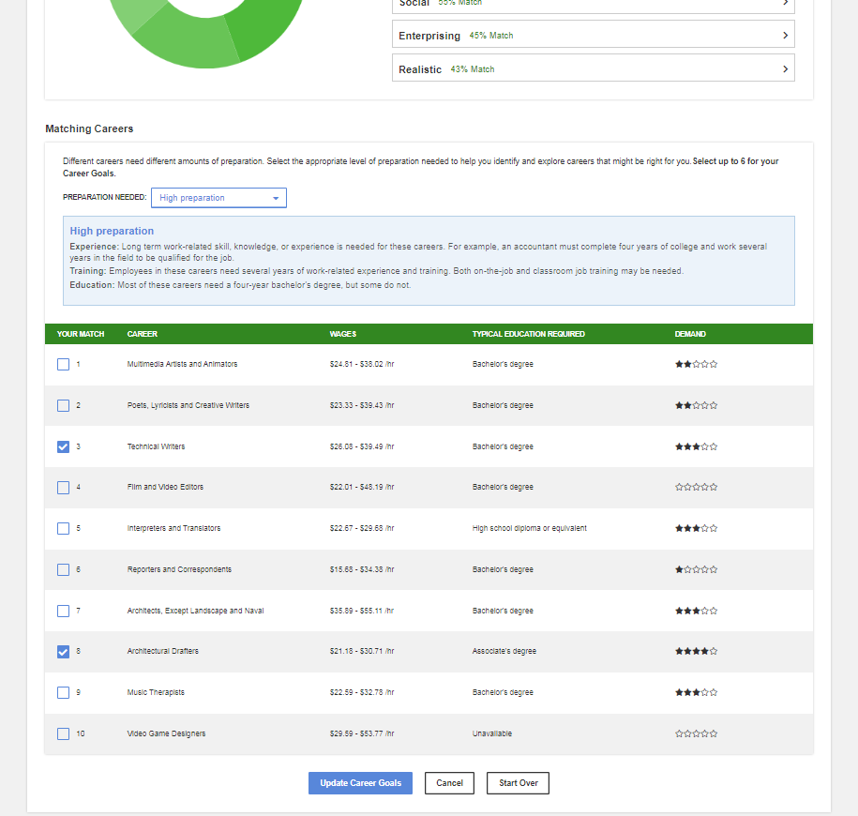

Step 8. Now these occupations will show up under your career goals. If you already have set career goals, you may need to remove some to make room for news ones that interest you.
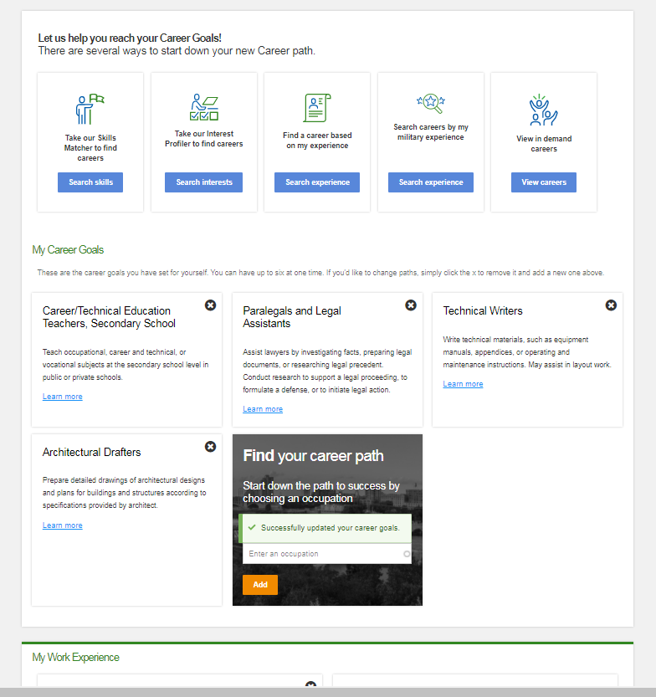

Step 9. To further refine your career goals, take a skills assessment. There are 40 questions and completing the assessment will take about 10 minutes. There are no right or wrong answers. Just answer in the way that best describes your current skills.
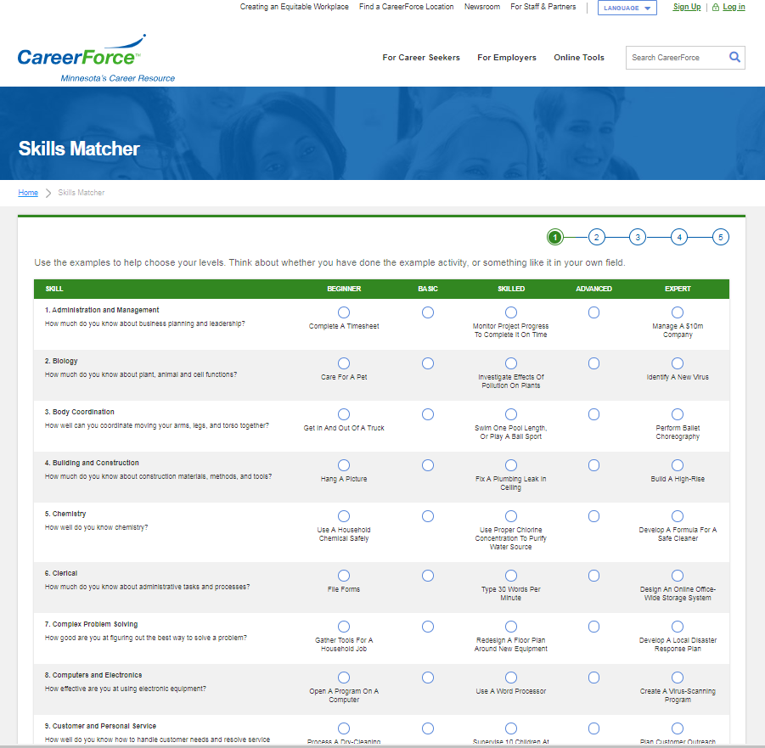

Step 10. After you complete and submit the skills assessment, the system reviews your responses and provides a list of your top 10 occupations matches, which you will see along with wage ranges for Minnesota, typical level of education required and demand (with a rating of stars for demand – no filled in starts means very little to no demand and five stars means very high demand). See results screen on the next page.

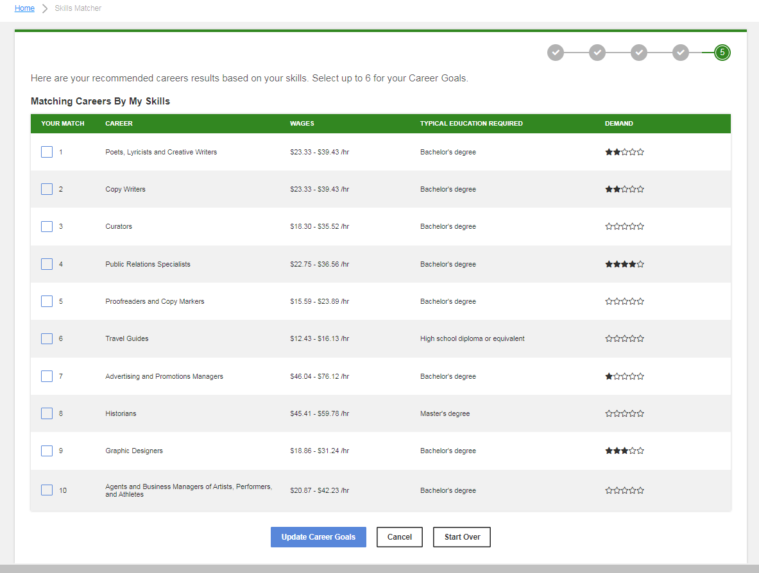

Step 11. Check the boxes under Your Match on the rows of occupations that match your skills and that you want to earn more about, then select Update Career Goals to add your selected occupations to your career goals and see additional details about those occupations and watch short videos about each occupation you select.

You can select up to six results to add to your career goals and see additional details about those occupations, as well as a short video. You need an account on CareerForceMN.com to set and save career goals and explore occupation details. It takes just a few minutes to set up your CareerForceMN.com. You will need an email address to set up an account.

Now these occupations will show up under your career goals. If you already have set career goals, you may need to remove some to make room for news ones that interest you.
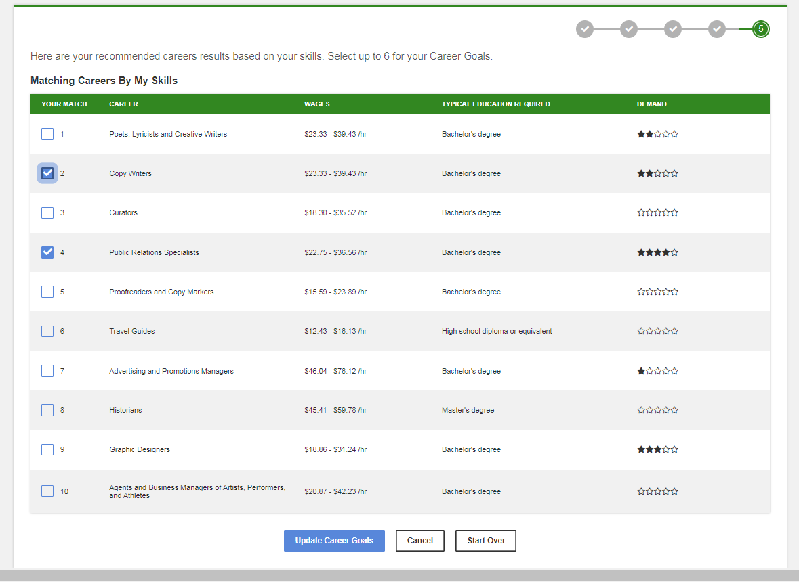

Step 12. Select up to six occupations to add to your career goals
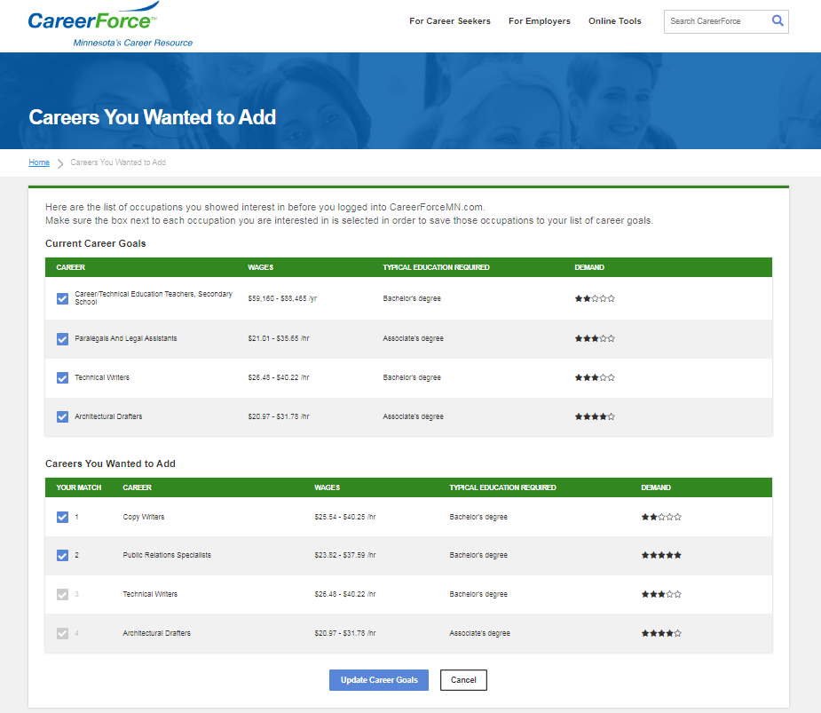

Step 13. Select Learn more on the box containing any of the career goals you selected and you will see a screen with full details about that occupation, as well as an embedded video about the occupation. If you no longer are interested in an occupation, you can remove it from you career goals by selecting the X at the top off the occupation box.

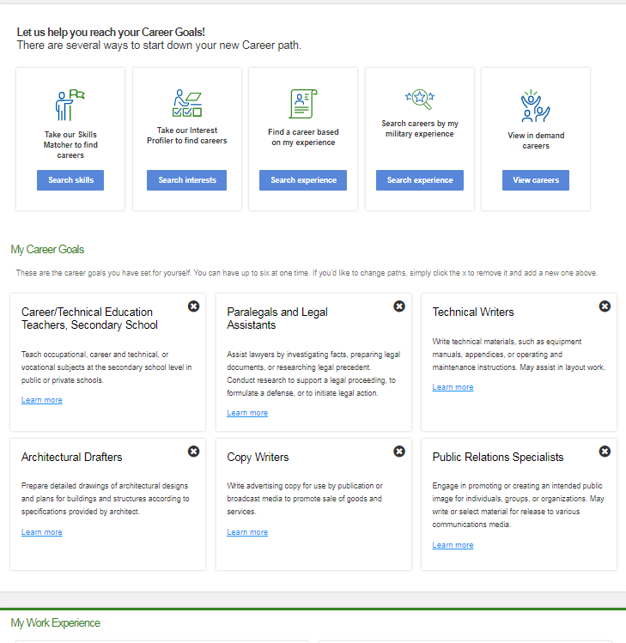

Step 14. View the occupation pop up for details for more information about occupations of interest to you.

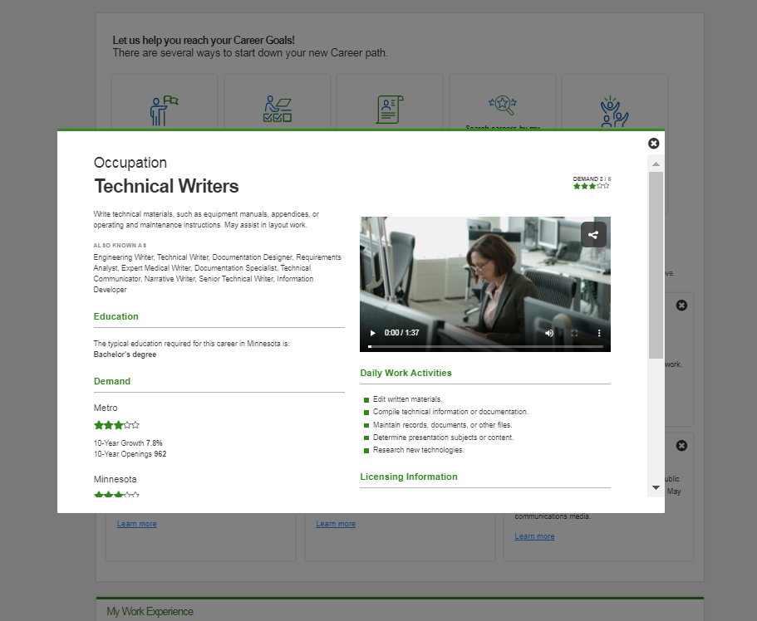

Using Holland Test Results to Explore Occupations on Onet.org

Step 1: Go to WWW.Onetonline.org.



Step 2: Go to the Advanced Search section toward the bottom of the Onet home page and click the small drop down arrow next to the text box.

Step 3: From the drop-down list of options click on Interests, and then icon.
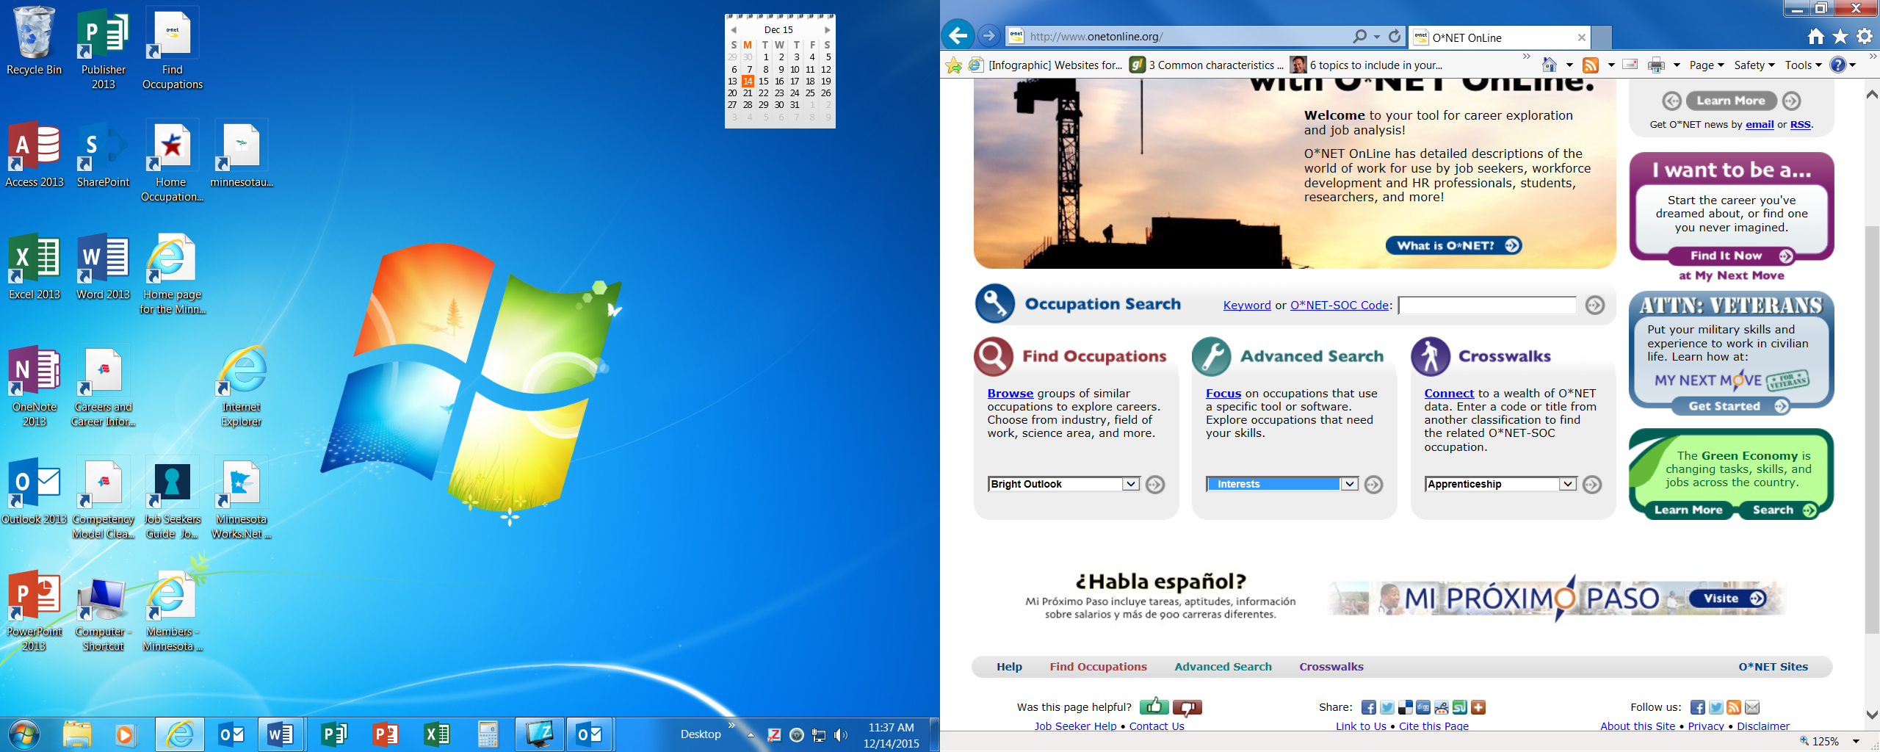.



A list of the six Holland work preference codes will be displayed.
Step 4: From the list of Holland codes click on your most dominant code.

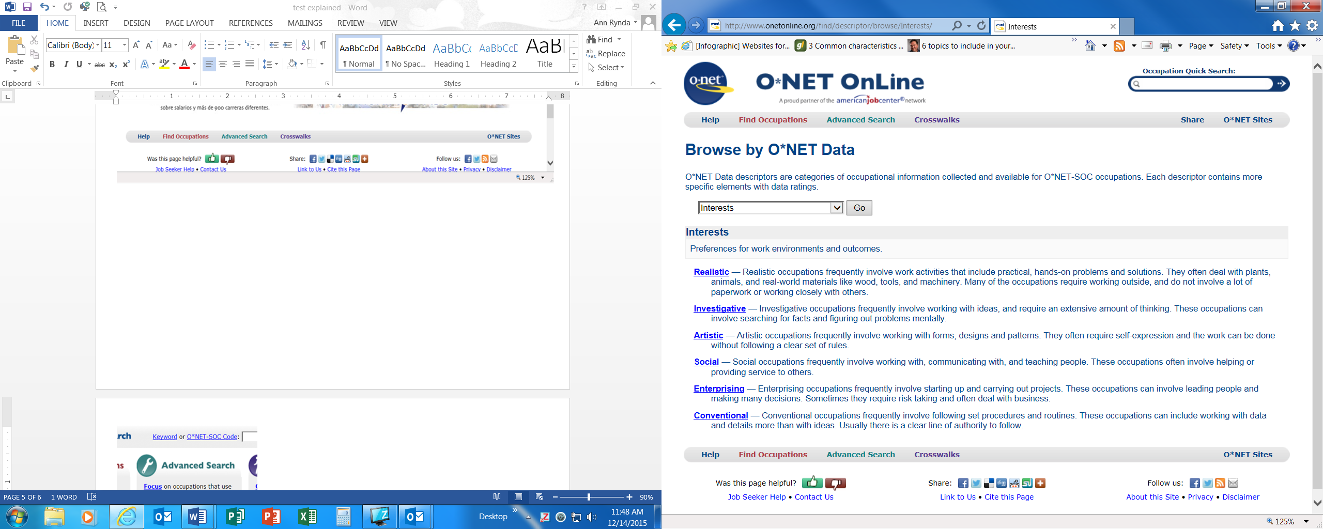

Step 5: Add in your second and third codes in the text boxes provided and click the Go button.

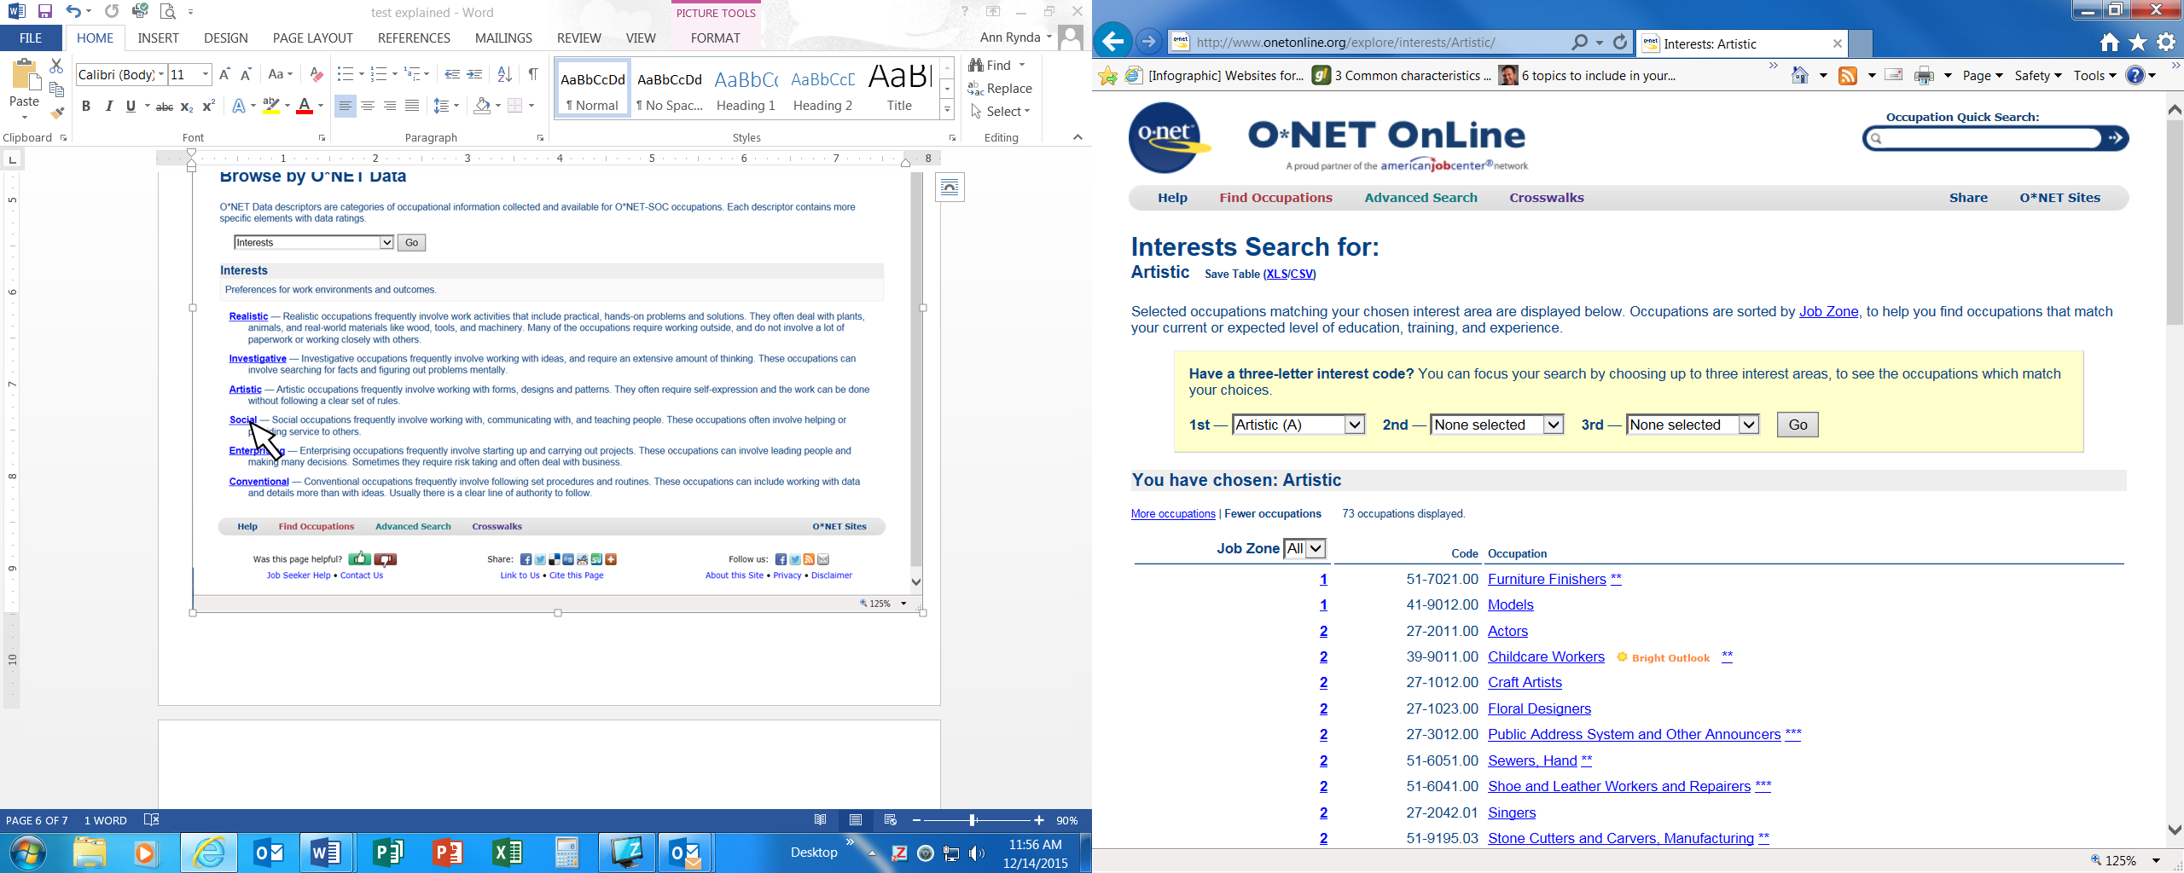
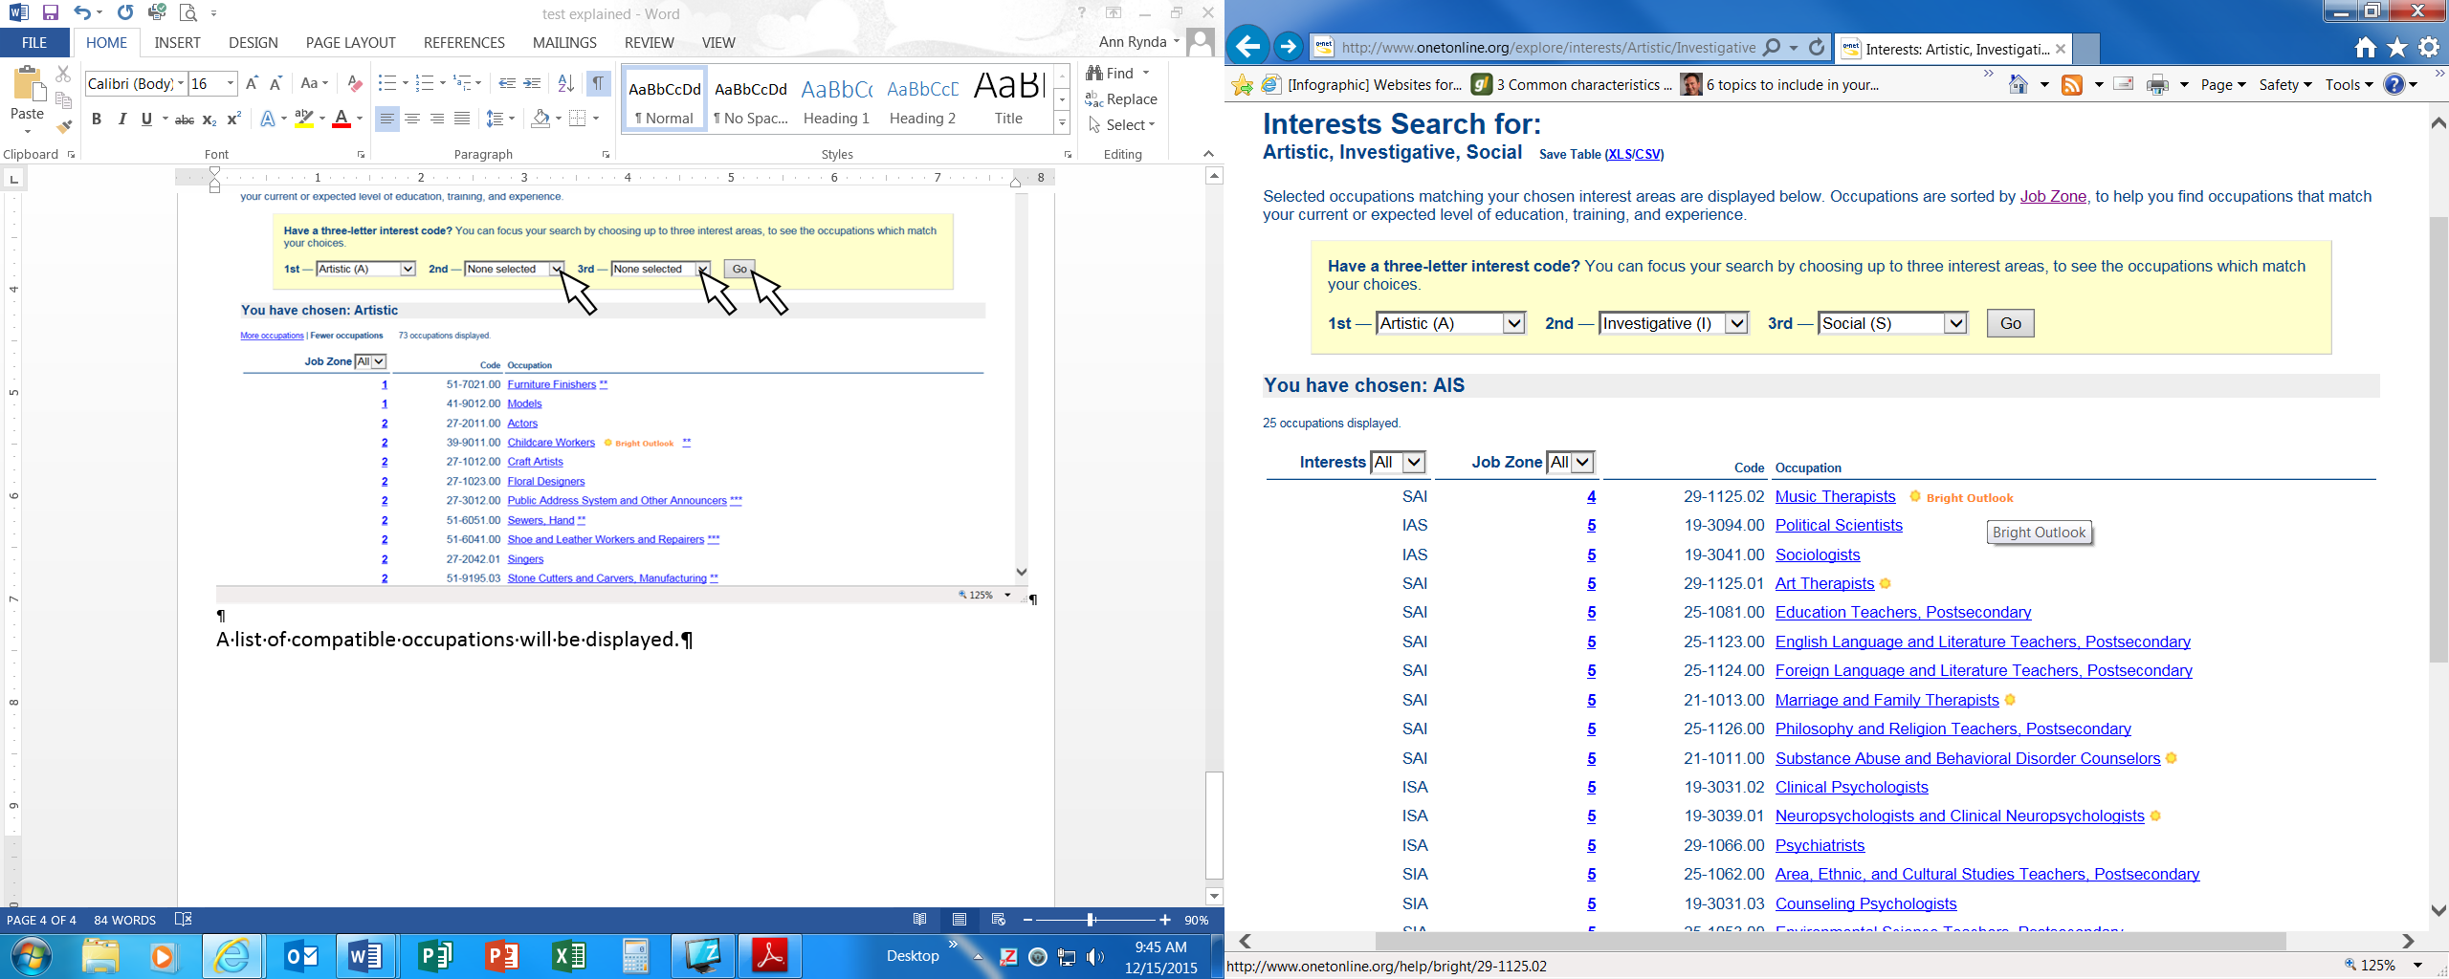

A list of compatible occupations will be displayed, (see above diagram).

Step 6: Select any job title from the list to get an in-depth summary report about this occupation. Job Zone numbers indicate how much training or education are typically needed to work in this occupation.

Job Zone Number | Level of education, training or preparation needed
1 | Elementary school level knowledge sufficient. Little or no training required.
2 | High School or GED needed. Some preparation needed.
3 | Some college or specialized training required. Medium amount of preparation needed.
4 | College degree required. Need considerable preparation.
5 | Advanced degree required. Extensive preparation needed.

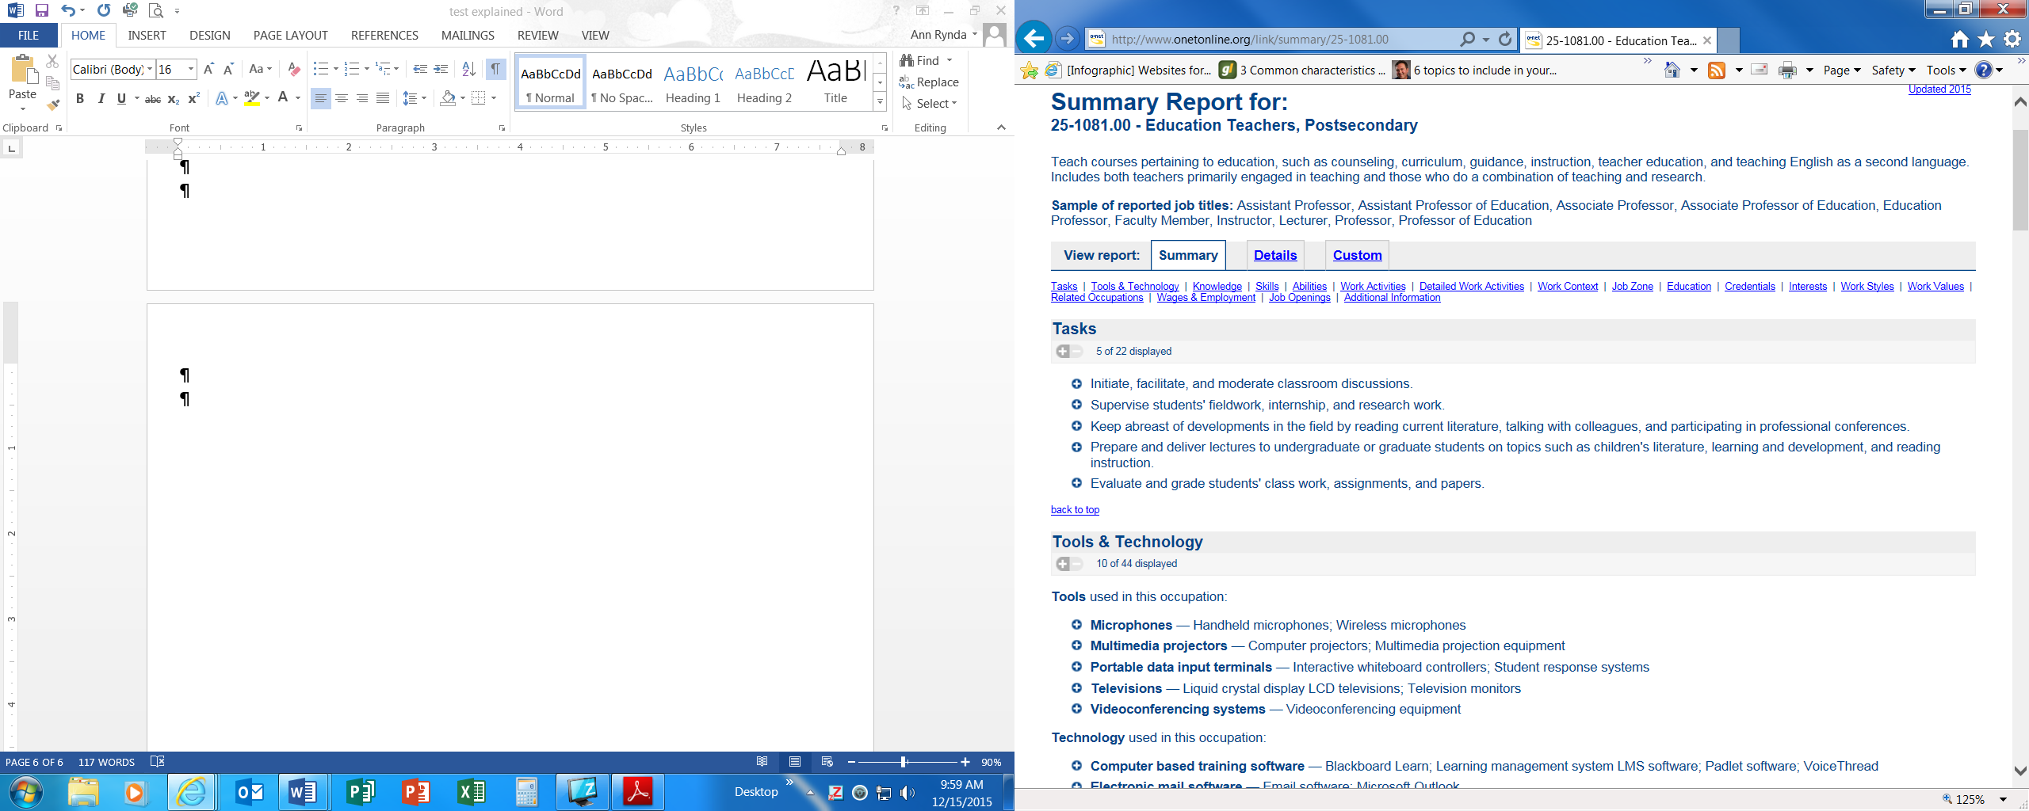

Helpful tips:
- Try searching using only your dominant code, or just your top two.
This will usually offer you a longer list of occupations.
- If your fourth code was close in score to your third code, try replacing the third code with the forth code. This may change the search results.
- Pull up the Summary Report of a career you are considering and view the Interests section to compare this work to your personal Holland codes.

Smart Goals Worksheet

You can learn how to set effective goals using the SMART method. SMART stands for:
Specific - What exactly do you want to do?
Measurable - How will you know when your goal is complete? Use numbers if possible.
Achievable - What resources will you use to complete your goal?
Relevant - Why is this goal important to your job search?
Timely - When will you complete this goal? Use specific dates.

Use the SMART method to set a goal in the worksheet below.

Goal

Specific
Example: I will make three new contacts in the healthcare industry.
Measurable
Example: I will get the names, titles and contact info for three people in healthcare
Achievable
Example: Cousin Jane (nurse), job club, LinkedIn, etc.
Relevant
Example: I want to work as a medical technician
Timely
Example: Complete in two weeks

