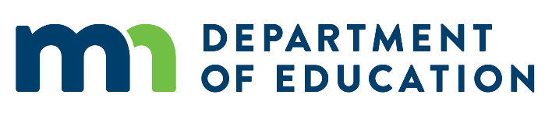

# Federal Adult Education Application Workforce Development Board Review

*Instructions: Please review your region’s/group’s local applications for federal Adult Education (ABE) funding, especially Section 6 (“Collaboration and Contextualization”). Once you have read the plan, complete this review form (one per applicant) and submit to Neill Allard at* [*neill@state.mn.us*](mailto:neill@state.mn.us) *by the end of the day on June 15, 2022.*

## Name of Applicant Organization:

## Name and/or Number of Board Reviewing Application:

## Question 1: Who is the primary representative leading the WIOA Title II application review from the workforce development board?

**Name:**

**Email:**

**Phone:**

## Question 2: How well does the application align to the current workforce development plan? (check one)

Highly Aligned

Moderately Aligned

Little to No Alignment

## Question 3: What specific parts in the reviewed sections of the application align to current workforce development plans?

## Question 4: What additional strengths do you see in this application?

## Question 5: What specific recommendations do you have about this application, including recommendations to improve alignment to the workforce development plan?

## Question 6: What questions do you have about this application, if any?