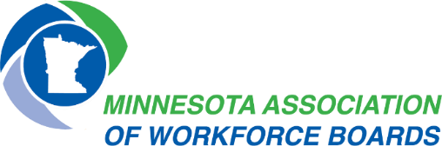
MAWB Operations Committee
Thursday, October 26, 2023
9:00 AM-2:00 PM
Hybrid

Mission: It is the mission of the Minnesota Association of Workforce Boards to provide Minnesota with a skilled and competitive workforce through engaged and proactive local elected officials, workforce development boards, and staff.

Agenda

9:00 AM Welcome and Introductions
- Approve Meeting Minutes and Agenda

9:05 AM Hot Topics
- How to make time for deeper/longer discussions- Elena
- Drive for Five- Elena
- Potential of shared positions for things like marketing and HR- Jinny
- Potential salary survey for field positions- Jinny
- REA Sessions- Nicole
- Federal Reserve Survey- Metro Directors
- Next Generation CNA Initiative- Jeanna
- Certification of Comprehensive Centers- Jeanna
- Certification of Local Boards- Jeanna
- Customer Tracking Updates- Jeanna

10:45 Break

11:00 GWDB Updates: Katie McClelland

11: 15 Director’s Report
- Legislative Platform and Federal Priorities (voting item)

11:45 AM MOU/IFA Check-In

12:15 PM Lunch
12:45 PM Workforce Division Updates: Marc Majors
1:00 PM Meet DEED Commissioner Matt Varilek
1:45 PM MAWB Committee Updates
- Jobseeker Services
- Business Services
- Legislative
- USCOM
- NACO
- WF1
- GLETA
2:00 PM Conclude

